Homework Problems for Monday January 16, 2017

- Read chapter 1 in Barron, interesting history and background for cryogenics.

- A Stainless Steel rod with a circular cross section of 15 mm diameter and a length of 3 meters connects room temperature (300 K) to a 5 K heat sink. Considering only conduction, what is the heat leak from 300 K to 5 K? What would be the heat leak if the rod were made of copper?

- List 2 effects of the significant decrease of specific heat of metals at cryogenic temperatures

- Calculate the Coefficient of Performance for an ideal Carnot Cycle Refrigerator operating between 300 K and 30 K. How many Watts of power at 300 K are required to remove 1 Watt of heat at 30 K using this refrigerator?

- For a helium expander with the following conditions:
18 bar inlet pressure, 2.0 bar exit pressure, efficiency = 70%
At approximately what inlet temperature would the exhaust become 2-phase?

Challenge question (not easy, but give this some thought!):
Intake valve in an expansion engine remains open for the entire intake stroke.
Thus entire intake stroke at higher pressure than entire discharge stroke.
Engine clearly does work, generates power.
But no isentropic expansion, no closed-cylinder expansion of any kind
Where does power come from? What gas properties change, and how? We’ll discuss that tomorrow.

- Identify the indicated components on the Collins cycle refrigeration plant schematic shown below:
A

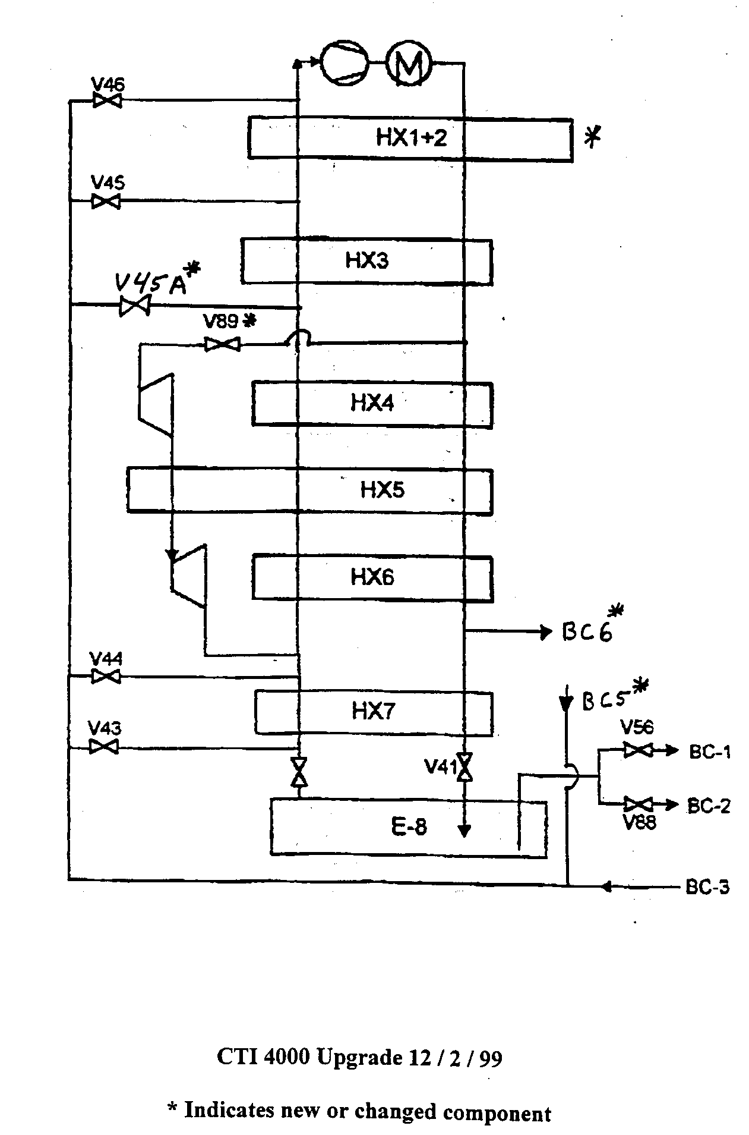
C
A:

B:

C:

D:

E:
E
D
B

Homework Problems for Tuesday January 17, 2017

- Consider 2 parallel plates each 2 m² in area. They are separated by 0.1 m. Their emissivity is 0.08 One plate is at 300 K and one is at 4.2 K. What is the heat leak due to radiation between the 2 plates? (assume the infinite plate approximation and assume that  = 0.08 is << 1 ).
- For the plates in question above; name 3 ways in which the radiation heat load to 4.2 K may be reduced.
- In cryostat design, what techniques do we use to reduce the conduction heat leak between room temperature and cryogenic temperatures?
- Describe the differences between a Type I and Type II superconductor. Why are Type II superconductors generally more useful for practical applications ?
- Suppose a short (30 cryomodules) ILC-like pulsed electron linac will operate with 2 K dynamic heat loads like those predicted for ILC but with gaseous helium cooling of the “40 – 80 K” thermal shield really at 40 – 60 K. (You may scale thermal radiation expected based on S1-Global 80 K measurements.) Describe whether you would recommend a 5 Kelvin thermal radiation shield between the 40 – 60 Kelvin thermal radiation shield and 2 K cold mass, or not recommend the 5 Kelvin thermal shield. Explain the reasons for your answer.

Homework Problems for Wednesday January 18, 2017

- 2 kW/m² pass through a heated wall. The surface of the wall is covered with He II at 1.8 K Assuming only Kapitza Conductance, what is surface temperature of the wall ? ( take alpha = 0.045 and m = 3)
- Consider a cylindrical tube of He II at 1 atm. The tube is 12 cm long and is 0.25 cm in diameter. One end of the tube is attached to an infinite heat sink kept at a temperature of 1.8 K. The other end of the tube is held at 2 K. Assuming Mutual Friction Heat transfer, how much heat is transferred through the tube? How much heat would be transferred between these temperatures in a piece of copper with the same length and diameter. Assume the thermal conductivity of the copper is constant and equals 20 W/mK
- List 3 rules of thumb or best practices to consider when designing cryogenic instrumentation systems
- Is a Platinum Resistor appropriate for measuring the temperature of a He II Bath? Why or Why Not?
- Consider a 1 meter long tube that is 5 mm ID connecting a 4.2 K bath and a 300 K sensor. The tube is sealed at the 300 K end. Assume that the midpoint between the 4.2 K temperature and the 300 K temperature occurs at the 0.5 meter point on the tube wall. Are thermoacoustic oscillations likely to occur in this tube?
- What two aspects make Oxygen Deficiency Hazards particularly dangerous?
- You are responsible for a small test facility for studying low temperature material properties. The lab includes one LHe test dewar filled from 500 liter portable liquid helium dewars. Describe some of the key ODH considerations for this room.

